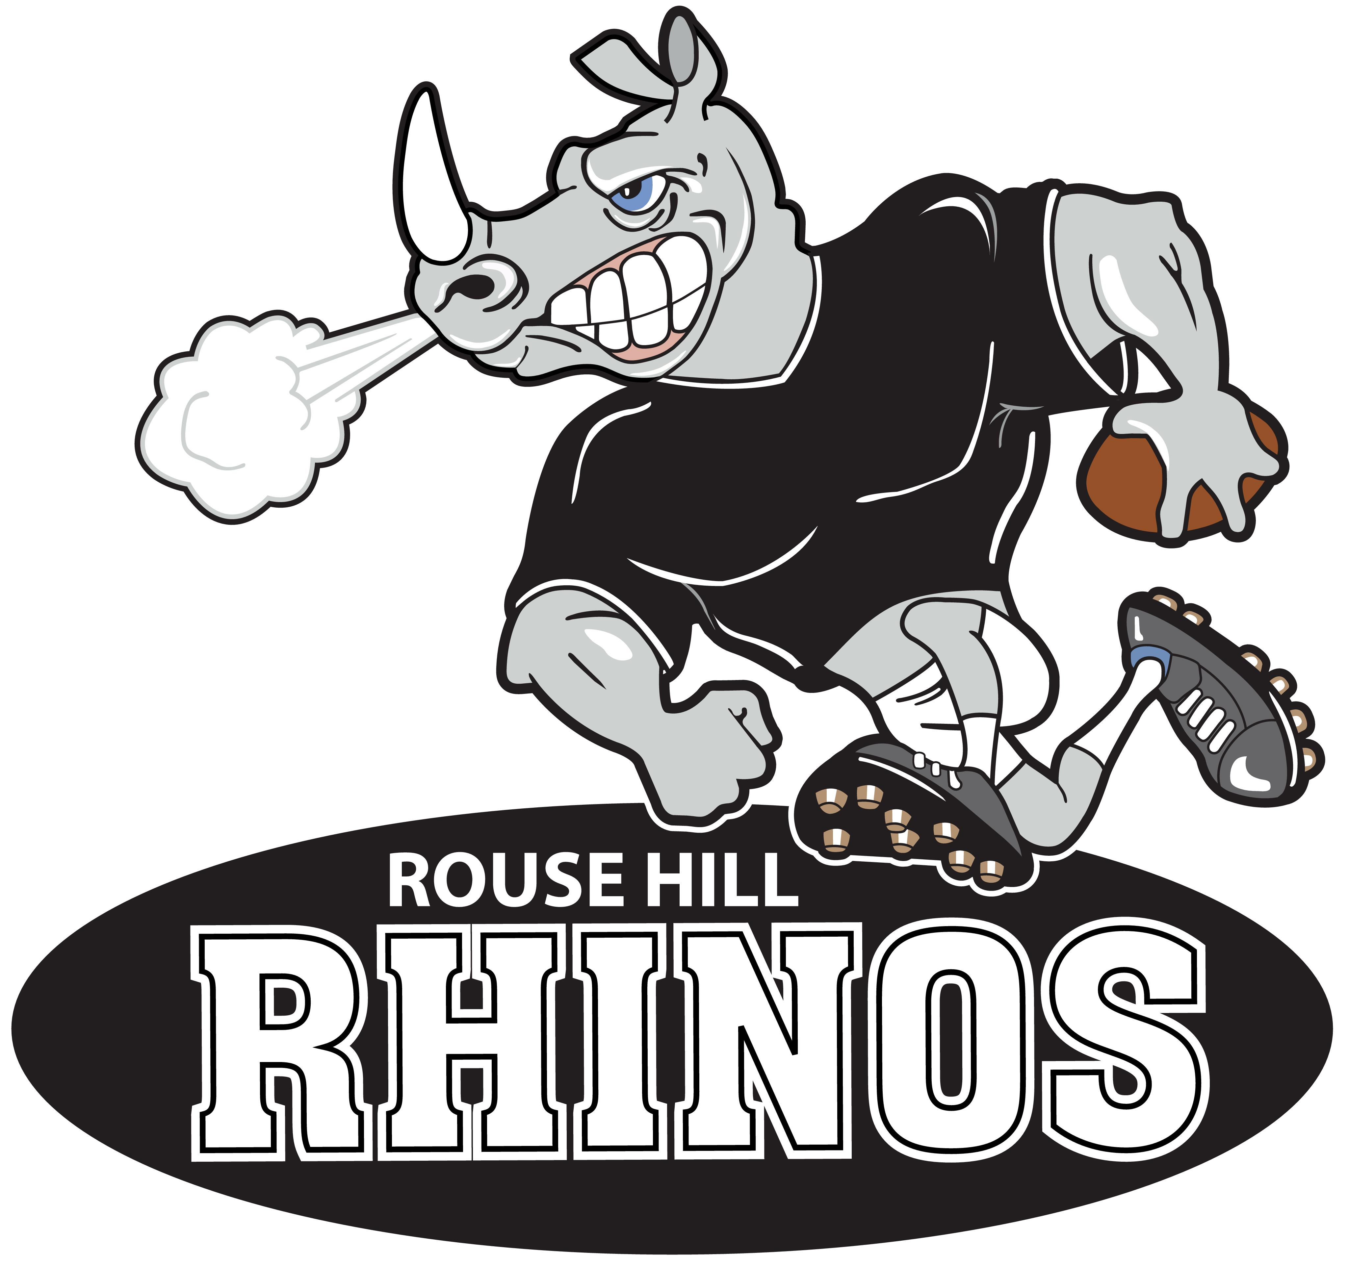

Rouse Hill Junior Rugby League Club

Coaching Application

PERSONAL DETAILS
Name
Address
Mobile
Email
COACHING QUALIFICATIONS & EXPERIENCE
Do you hold a current coaching certificate? |  |  |  |  | Yes / No
What level is the qualification? (circle those that apply) |  |  |  |  | MGC (Modified Games Coach)  IGC (International Games Coach)  CC (Club Coach)
NRL ID # |  |  |  |  | Working With Children’s #
Coach / Trainer History – Please provide details of previous coaching/training history
Year | Club |  | Age | Division |  | Comments – please specify role
2020
2019
Which team do you wish to coach ?

What is your coaching philosophy?
SPONSORSHIP
Do you have, or know of a sponsor who might be interested in sponsoring your team? |  |  | Yes / No
Sponsor name
Sponsor phone
Sponsor email
DECLARATION
All information on this application is true and correct.
I have read and agreed to abide by the ‘NRL Code of Conduct’ at all times. I understand that should I fail to do so I may be sanctioned by the NSWRL and/or Club which may result in me forfeiting the privilege of coaching my team.
I understand as a coach, that I will be required to attend all scheduled Coaches and Managers meetings.

Signed
Date

Please email your application to president@rousehillrhinos.com.au

